**Experiment No : 9**

**Aim :**To apply PCA on n Dimension inbuilt dataset.

**Theory :**

Principal Component Analysis (PCA) is used to explain the variance-covariance structure of a set of variables through linear combinations. It is often used as a dimensionality-reduction technique. It is the process of computing the principal components and using them to perform a change of basis on the data, sometimes using only the first few principal components and ignoring the rest. It is a technique for reducing the dimensionality of such datasets, increasing interpretability but at the same time minimizing information loss. It does so by creating new uncorrelated variables that successively maximize variance.

**Dataset used :** Inbuilt hald dataset

**Code :**

clc;

clear all;

close all;

load hald

X = pca(ingredients)

plot3(X(:,1),X(:,2),X(:,3),'bo');

grid on;

**Output :**

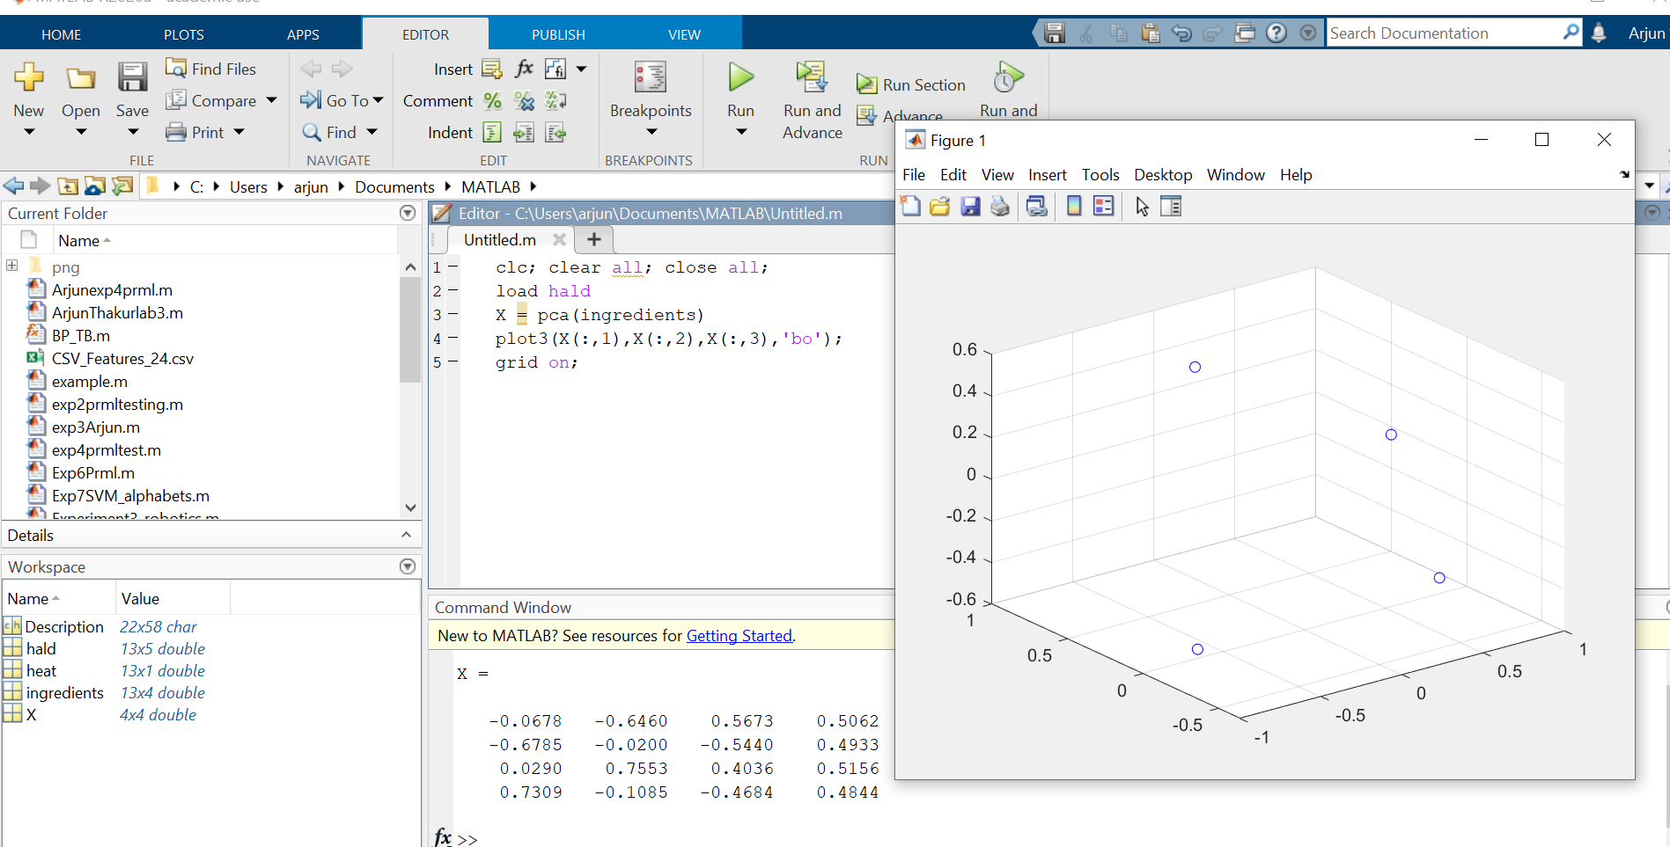

**Conclusion** : Thus, after performing the experiment , I understood how Principle component analysis performs dimensionality reduction, how it extracts the important information from a multivariate data table and to express this information as a set of few new variables called principal components on inbuilt dataset ‘hald” using inbuilt function “ pca (ingredients) “ & observing the X matrix in command window all successfully on MATLAB.